Logistic Regression :

* Logistic regression is a statistical method for predicting binary classes. The outcome or target variable is dichotomous in nature.
* Linear Regression Equation:

http://res.cloudinary.com/dyd911kmh/image/upload/f_auto,q_auto:best/v1534281880/image1_ga8gze.png

Where, y is dependent variable and x1, x2 ... and Xn are explanatory variables.

* Properties of Logistic Regression:
* The dependent variable in logistic regression follows Bernoulli Distribution.
* Estimation is done through maximum likelihood.

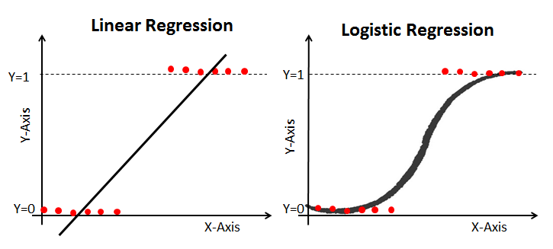

### Maximum Likelihood Estimation Vs. Least Square Method

The MLE is a "likelihood" maximization method, while OLS is a distance-minimizing approximation method. Maximizing the likelihood function determines the parameters that are most likely to produce the observed data. From a statistical point of view, MLE sets the mean and variance as parameters in determining the specific parametric values for a given model. This set of parameters can be used for predicting the data needed in a normal distribution.

Ordinary Least squares estimates are computed by fitting a regression line on given data points that has the minimum sum of the squared deviations (least square error). Both are used to estimate the parameters of a linear regression model. MLE assumes a joint probability mass function, while OLS doesn't require any stochastic assumptions for minimizing distance.

Confusion Matrix:

A confusion matrix is a table that is used to evaluate the performance of a classification model. You can also visualize the performance of an algorithm. The fundamental of a confusion matrix is the number of correct and incorrect predictions are summed up class-wise.

array([[119, 11],

[ 26, 36]])

Here, you can see the confusion matrix in the form of the array object. The dimension of this matrix is 2*2 because this model is binary classification. You have two classes 0 and 1. Diagonal values represent accurate predictions, while non-diagonal elements are inaccurate predictions. In the output, 119 and 36 are actual predictions, and 26 and 11 are incorrect predictions.

#### ROC Curve

Receiver Operating Characteristic(ROC) curve is a plot of the true positive rate against the false positive rate. It shows the tradeoff between sensitivity and specificity.

y_pred_proba = logreg.predict_proba(X_test)[::,1]

fpr, tpr, _ = metrics.roc_curve(y_test, y_pred_proba)

auc = metrics.roc_auc_score(y_test, y_pred_proba)

plt.plot(fpr,tpr,label="data 1, auc="+str(auc))

plt.legend(loc=4)

plt.show()

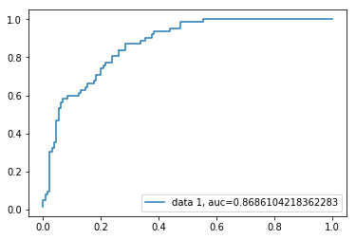

AUC score for the case is 0.86. AUC score 1 represents perfect classifier, and 0.5 represents a worthless classifier.

### Advantages

Because of its efficient and straightforward nature, doesn't require high computation power, easy to implement, easily interpretable, used widely by data analyst and scientist. Also, it doesn't require scaling of features. Logistic regression provides a probability score for observations.

### Disadvantages

Logistic regression is not able to handle a large number of categorical features/variables. It is vulnerable to overfitting. Also, can't solve the non-linear problem with the logistic regression that is why it requires a transformation of non-linear features. Logistic regression will not perform well with independent variables that are not correlated to the target variable and are very similar or correlated to each other.